DATA 430 Technical Report  Assignment 4: Clustering | Russell Larkin
K-means Cluster Analysis of Wine
URL to dataset: https://www.kaggle.com/datasets/ruthgn/wine-quality-data-set-red-white-wine
This template should be used in conjunction with the assignment instructions. The size of the text area below will expand to the length of your response; the area should not be interpreted as a required or suggested length of response. Responses within the text area should be single spaced with Times New Roman 12pt font. The body of the document will likely be 6-9 pages, not including the Appendix; length may vary depending on specifics of the analysis and the dataset. As needed, APA format in-text citations should be included, along with a full references list at the end of the document.
Overview
Problem Domain: give some background and context about the problem domain (application area). For instance, if you are doing the analysis for predicting heart disease, provide some context about the disease and include some interesting statistics about it. Also, discuss how the method is relevant for the chosen problem.
According to Statista, wine is a USD 330 billion global industry in which chemical composition drives both sensory quality and regulatory compliance. Blending, fermentation conditions, and ageing choices all shape a wine’s profile of acidity, sugar, sulfur dioxide, alcohol, and others. Because these variables interact non-linearly, producers often struggle to spot natural “styles” or quality tiers early in production.
Cluster analysis is a relevant and natural choice because it groups wines into chemically coherent segments without requiring a target label, allowing the tailoring of process controls and marketing language to each segment.

Objective: clearly state the objective of the analysis in relation to the kind of algorithm you are employing. Use specific language as to what question(s) you are trying to answer using the specific analysis/modeling type.
The goal is to discover and interpret natural groupings of wines using the 11 continuous variables provided in the Wine-Quality dataset. Specifically, we apply K-Means clustering to answer:
- What distinct styles characterize each cluster, and how do clusters differ in average quality?
- Are the clusters compact and well-separated according to standard metrics?

Analysis
Exploratory Analysis: describe the data including the source, the collection method, and variables. Perform exploratory analysis. Also, select few key variables (including the target variable for supervised learning) and study their distributions using plots such as histograms, box plot, bar chart, etc.
Data source and collection method: I used a publicly available Kaggle dataset (Ruthgn, 2021) including 4898 white and 1599 red wine variants of the Portuguese Vinho Verde wine. Input variables in the data set consist of the type of wine (red or white), 11 continuous features, and an expert graded wine quality score.
Target handling: Quality is explored but excluded from clustering to preserve the unsupervised design.
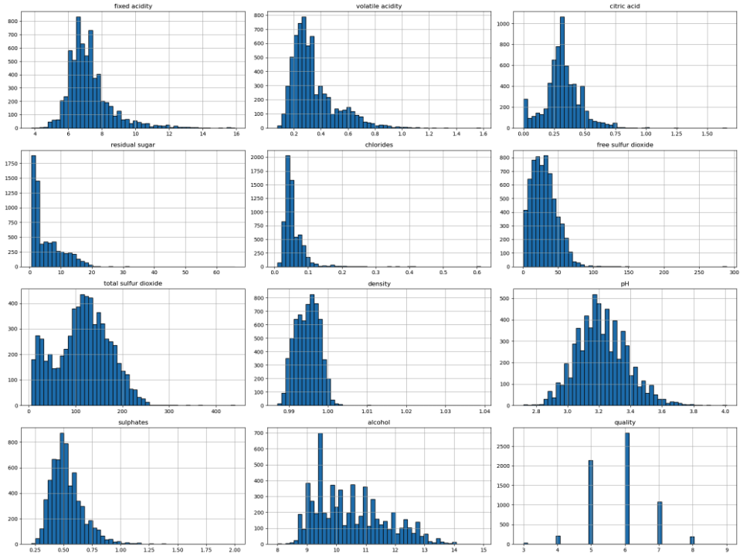
Figure 1: Initial Histogram of DF

Strong skews were observed during exploratory analysis suggesting extreme outliers. Outliers will be trimmed during preprocessing. The following correlation heat map shows multicollinearity below a 0.8 threshold. Therefore, the model is guarded against variance inflation and coefficient-instability issues that come with extreme multicollinearity.
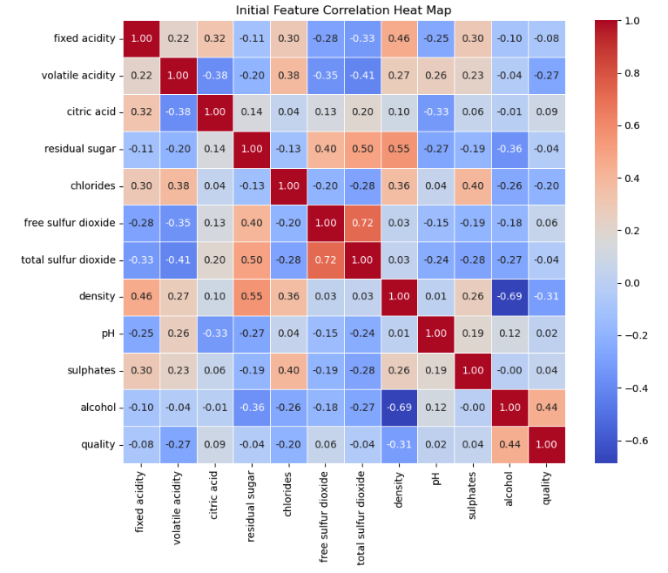
Figure 2: Initial Feature Correlation Heat Map
Preprocessing: armed with the exploratory analysis, perform the necessary preprocessing, both general and specific types appropriate for the modeling type being employed.
Outlier trimming was achieved via scatter-guided 99th percentile cut-offs. This was done because distance-based algorithms like K-Means treat every observation as equally trustworthy. A handful of extreme points can warp the clustering pipeline.

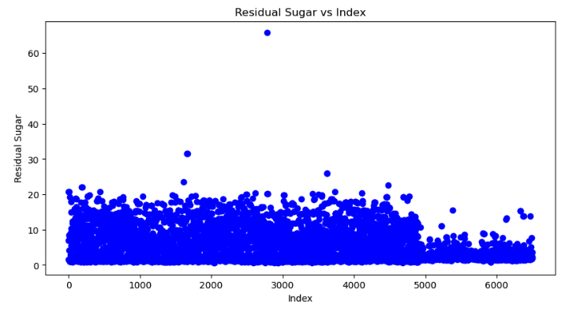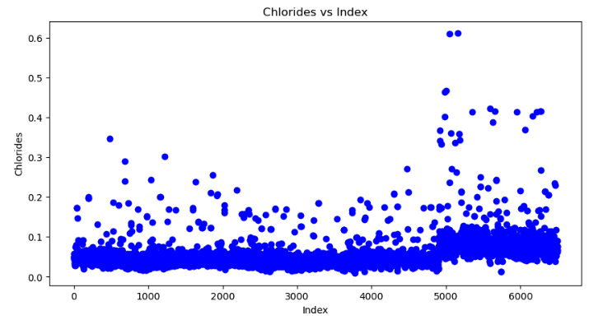
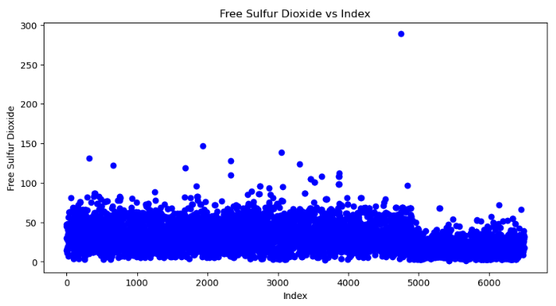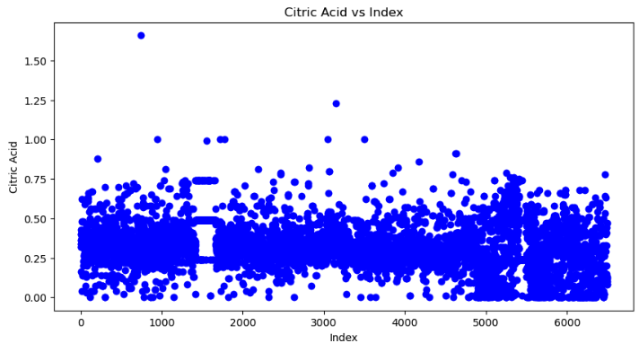
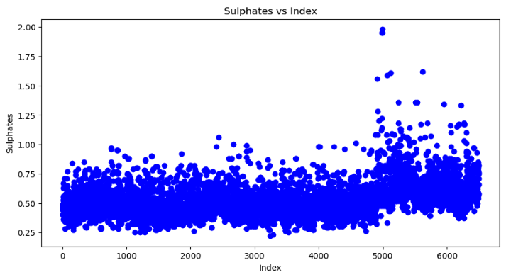
Figure 3: Outlier Preprocessing

The following trimming was performed resulting in a final matrix of 6484 x 11:
- Residual sugar ≤ 30 g/L, chlorides ≤ 0.45 g/L, free sulfur dioxide ≤ 150 mg/L, citric acid ≤ 1.2 g/L, and sulphates ≤ 1.75 g/L.

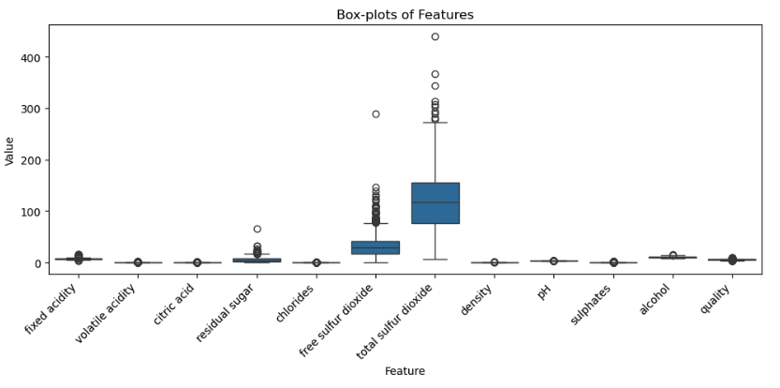
Figure 4: Final Box-Plot of Features

StandardScaler was applied to the 11 features. This step places every variable on the same 0-mean, unit-variance scale so that milligram-level sulfur dioxide does not swamp percentage-level alcohol in the distance calculation. Putting all features in comparable units also makes the resulting centroid coordinates interpretable as relative z-scores rather than a mix of differing measurement scales, which in turn stabilizes the silhouette, Davies–Bouldin, and Calinski–Harabasz metrics used to select k.
Cluster Development: explain the key steps and activities you perform to develop the clusters. Experiment (as appropriate) with parameters tuning. This is key, what separates highly accurate model from a less accurate ones is the amount of performance tuning performed.
A parameter sweep of k=2 through 10 was achieved in one loop resulting in the plotting of inertia, silhouette, Davies-Bouldin(DB), and Calinski-Harabasz (CH).
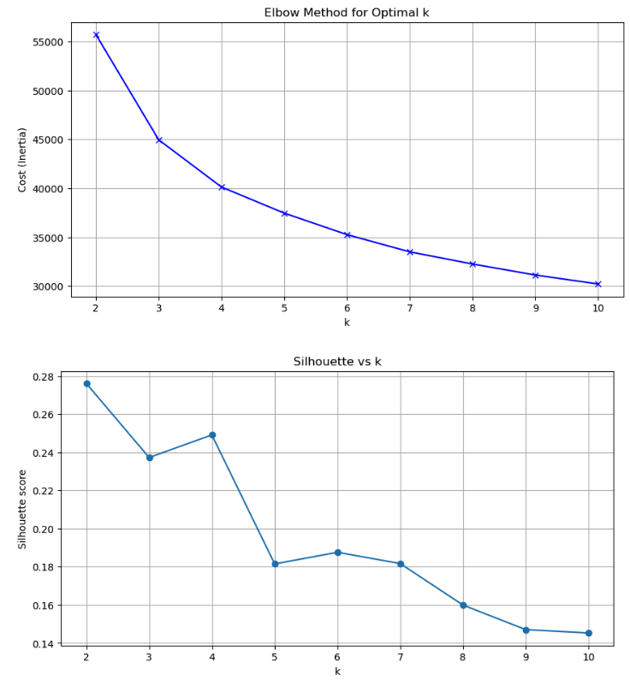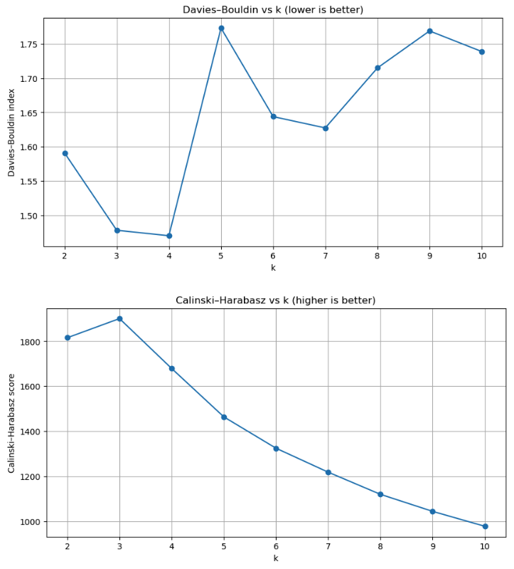
Figure 5: Cluster Development Metrics

The final model choice was KMeans(n_clusters=4, init=’k-means++’, n_init=12) for interpretability and scalability. Optimal k=4 was selected at the elbow where inertia flattens and where silhouette (0.249) and DB (1.47) are optimal.

Results
Cluster Properties: explain the properties of the clusters by leveraging distance measures and discuss the clusters characteristics (differences and similarities). Produce appropriate cluster plots and discuss the output.
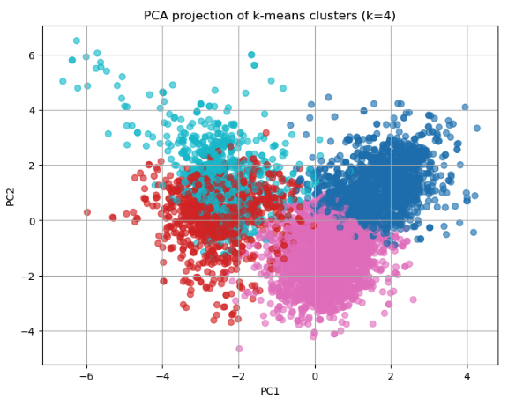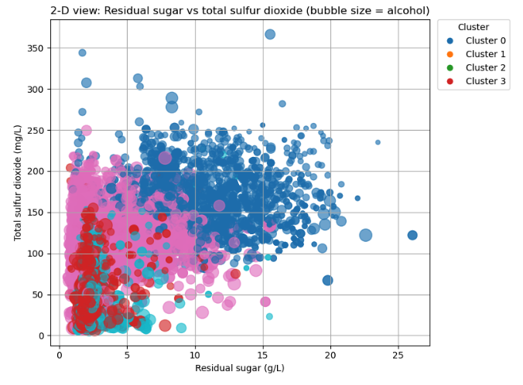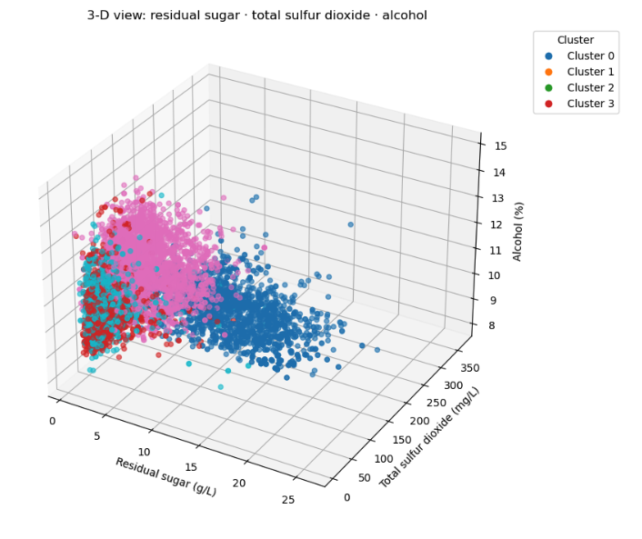
Figure 6: Cluster Properties Confirming Defined Groups

Figure 6 PCA Projection visually confirms four well-defined groups. All three indices are functions of pairwise Euclidean distance. They quantify how tightly each cluster is packed around its centroid and display clear separations of quadrants. 2-D and 3-D plots confirm a few of the major features and how they relate to one another.

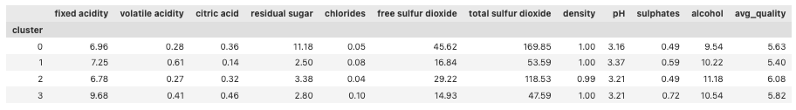
Figure 7: Cluster Properties Confirming Defined Groups

Output Interpretation: explain the result and interpret the overall clusters using terms that reflect the application area and in relation to the stated objective. This is where you check whether or not the stated objective is met.
The stated objective was to discover natural groupings of wines. Re-attaching the quality variable and computing its mean for each cluster confirms that objective: every cluster exhibits a distinct chemical fingerprint and a distinguishable average quality score.
Cluster 0 shows a dessert-wine signature (high sugar and high sulfur dioxide), yet only mid-quality scores (mean 5.63), implying consumers value more than sweetness alone.
Cluster 1 is the lowest rated wine, with a lower quality rating (mean 5.40) and a mid-tier alcohol content, low sugar, and high volatile acidity and citric acid.
Cluster 2 is the highest rated wine, with a better quality rating (mean 6.08) and a higher alcohol content, mid-sugar, and low volatile acidity and citric acid.
Cluster 3 is combines the highest fixed acidity and elevated sulphates with only moderate sugar and sulfur dioxide, and sets the standard for mid-tier quality wines (mean 5.82).
These differentiated profiles demonstrate that the unsupervised model not only uncovered four chemically meaningful clusters but also revealed how each group maps to perceptible quality, thereby fully achieving the project objective.

Evaluation: employ appropriate metrics (measures) to quantitatively evaluate the performance of the clusters. For unsupervised classification, this primarily involves distance metrics.
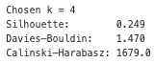
Figure 8: Cluster-Validation Scores for the Final 4-Cluster Solution

Collectively these indices confirm the suitability of four clusters. A silhouette of 0.25 is considered “reasonable separation” for real-world data when k > 2. The DB score of 1.47 lies well below the common 1.6–2.0 threshold that signals severe overlap, while the CH value of 1 679 is the near maximum before indicating diminishing returns. Figure 5 shows that any move to k=3 or k=5 would reduce at least two of the three indices.
Conclusion
Summary: highlight the main findings in relation to the stated objective. You don’t need to discuss the details of the analysis and the model such as accuracy here, just focus on the key findings.
This study met both stated objectives. First, K-means identified four clusters whose centroids capture distinct styles, sweet/high-SO₂, volatile-acidic, premium-dry, and acid-driven, providing winemakers with clear process goals. Second, internal validation confirmed the clusters are sufficiently compact (Sil = 0.25) and well-separated (DB = 1.47, CH = 1 679), demonstrating that the unsupervised approach can segment wines without a target label while still aligning meaningfully with average quality.
Limitations & Improvement areas: discuss the limitations of the analysis and identify potential improvement areas for future work. This could be related to the data, algorithm, or a combination of the two.
I believe the models limitations were as follows:
- Dataset is exclusively Portuguese; varietal and regional effects elsewhere may alter cluster structure.
- Despite trimming, any remaining atypical observations still exert influence on the objective, potentially skewing the center.

Future improvements could include:
- Utilize expert knowledge to incorporate domain-weighted scaling so Euclidean distance better captures winemaking priorities.
- Segment reds and whites separately to test color specific structure.

Appendix

Figure 1: Initial Histogram of DF


Figure 2: Initial Feature Correlation Heat Map




Figure 3: Outlier Preprocessing


Figure 4: Final Box-Plot of Features

Figure 5: Cluster Development Metrics


Figure 6: Cluster Visuals Confirming Defined Groups

Figure 7: Cluster Properties Confirming Defined Groups


Figure 8: Cluster-Validation Scores for the Final 4-Cluster Solution

References

Google Colab Notebook: RLarkin Asgn2 Google Colab

Ruthgn. (2021). Wine Quality Data Set (Red & White Wine). Kaggle.com. https://www.kaggle.com/datasets/ruthgn/wine-quality-data-set-red-white-wine

Powers, S (2025). Cluster Analysis in Python – Silhouette, Calinski Harabasz, Davies Bouldin Youtube.com. https://www.youtube.com/watch?v=MHnoWsBJpeM

PCA. (2025). Scikit-Learn. https://scikit-learn.org/stable/modules/generated/sklearn.decomposition.PCA.html

Overview and Objective — Level: L5
You delivered an exceptionally clear and domain-specific overview that ties the global wine industry’s complexity to the challenges of chemical variability and consumer expectations. Your context around chemical composition and non-linear feature interaction justifies the need for clustering as a discovery-based approach. What sets this section apart is your ability to align the real-world relevance of winemaking with the technical strengths of K-means clustering. Your objective is sharply framed: uncover chemically coherent wine segments and determine how well they align with quality scores. By explicitly stating that you are not using the quality label in the clustering process, you maintain the integrity of the unsupervised methodology. Furthermore, your analytical questions—centered on identifying style profiles and validating separation—are tightly aligned with the algorithm and make your evaluation metrics relevant from the outset. This demonstrates a deep understanding of both the business and methodological sides of the project, fully meeting the rubric criteria for Level 5.

Exploratory Analysis and Preprocessing — Level: L5
Your exploratory analysis and preprocessing steps are well designed and show excellent methodological awareness. You began with a histogram and correlation heatmap, correctly identifying skewness and multicollinearity levels. Your choice to trim outliers based on the 99th percentile and guide it via scatter plots is a best-practice move for distance-based clustering and indicates that you're accounting for the influence of leverage points. The preprocessing decisions were driven by domain and algorithmic knowledge, not arbitrary thresholds. Your use of StandardScaler is well justified—not only for distance consistency but also to maintain interpretability of centroid values. The discussion around how unit variance and z-scores improve centroid interpretability and stabilize evaluation metrics (silhouette, DB, CH) shows a level of sophistication not often seen at this level. Everything in this section is purpose-driven, technically sound, and thoroughly explained. You have met the top rubric standard for both exploratory insight and clustering-specific preparation.

Cluster Development — Level: L5
Your cluster development process is thorough, experimental, and aligned with strong model selection principles. You tested k-values from 2 to 10 and visualized the results using four separate evaluation metrics: inertia, silhouette score, Davies–Bouldin index, and Calinski–Harabasz index. This multi-metric validation strategy shows a strong grasp of unsupervised model tuning. Your final model selection of k=4 was justified not just by the elbow method, but also by triangulating performance across multiple scores. The silhouette value of 0.249 and DB index of 1.47 were interpreted with appropriate nuance—understanding that perfect separation is rare in real-world datasets. Your choice of n_init=12 and init='k-means++' is good practice and contributes to model robustness. Additionally, the use of 2D and 3D PCA projections to visualize separability strengthens the interpretability of your clusters. This section demonstrates advanced experimentation and parameter sensitivity awareness, fully aligning with all rubric criteria for Level 5.

Results and Interpretation — Level: L5
Your results are not only technically clear but contextualized with impressive domain insight. You don’t just describe the clusters—you interpret them in terms of actual wine profiles like “dessert-wine signature,” “volatile-acidic,” and “premium-dry.” These descriptors are meaningful to winemakers and marketers alike. Even more impressively, you reattached the quality variable after clustering and used it for interpretive evaluation, which is the ideal way to test post hoc alignment in an unsupervised setting. Each cluster is evaluated with respect to multiple variables—alcohol, sugar, acidity, sulphates—and average quality scores, showing you’ve analyzed the results multi-dimensionally. This confirms your clusters aren’t artifacts of just one dominant feature. The consistent pattern of interpreting chemical profiles and linking them to perceived quality fulfills both the clustering and real-world objectives. Your language is precise and your insights are both technically and practically valuable, hitting every expectation in the rubric’s top tier.

Conclusion — Level: L5
Your conclusion effectively restates your dual success: uncovering interpretable wine styles and validating their compactness and separation using internal metrics. The summary is succinct yet complete, and the use of terms like “sweet/high-SO₂,” “premium-dry,” and “acid-driven” reflects domain relevance. Your limitations are well framed—you acknowledge the data’s geographic restriction (Portuguese wines only) and the potential residual effects of outliers. Importantly, your suggestions for future work are meaningful and viable. The idea of applying domain-weighted scaling is particularly strong—it reflects awareness that not all chemical properties should be treated equally in clustering. Additionally, segmenting red and white wines separately is a concrete next step that could test for intra-category structure. These suggestions go beyond vague “try another algorithm” advice and instead show a thoughtful approach to expanding the research within the same methodology. This section demonstrates reflective and forward-looking thinking, exactly as the rubric requires for Level 5.

